W6 - PRACTICE
List display - Conditional display

 At the end of his practice, you should be able to…
- Manage dynamic style
- Conditional display
- Display a list of data
- Pass data to nested components using props

 How to work?
- Download the start code from the Google classroom
- For each exercise you can either:
  - Run npm install
  - Or move an existing node_modules to the exercise folder (fastest option!)

How to submit?
- Create a repository on GitHub with the name of this practice:
Ex: C2-S1-PRACTICE
- Push your final code on this GitHub repository (if you are lost, follow this tutorial)
- Finally, submit on Google classroom your GitHub repository URL
Ex: https://github.com/thebest/ C2-S1-PRACTICE.git

Warning: this practice will be evaluated by peer next sessions

 Are you lost?
You can read the following documentation to be ready for this practice:
https://www.w3schools.com/react/react_jsx.asp
https://www.w3schools.com/react/react_props.asp
https://www.w3schools.com/react/react_conditional_rendering.asp
https://www.gatsbyjs.com/docs/how-to/images-and-media/importing-assets-into-files/

THE GOAL…

The goal of this practice is to display students' results in different courses (HTML, Java…) using well-formatted tables.
We want especially to highlight students' score lower than 50.

To perform this project, we will go step by step: make sure that you successfully achieve each step before going further!

Are you ready? See you on the next page then! 😊

The finished app will look like this:
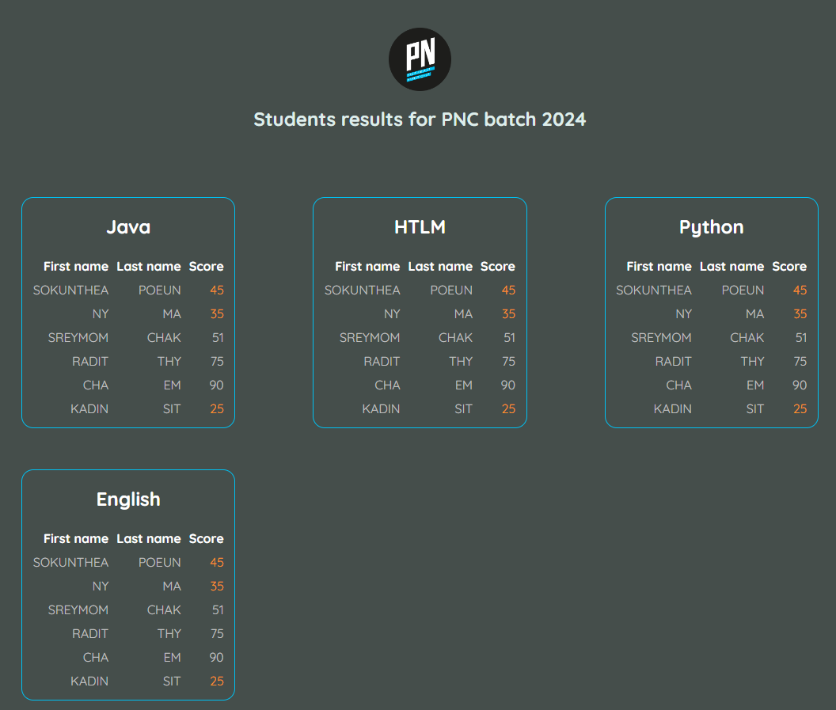

STEP 1 – CREATE THE HEADER COMPONENT
Ready?

In this first step, you need to create a component Header (Header.jsx file in folder /components)
- This component shall display the logo and the title of the page.
- This component shall get as a parameter the name of the batch

Be careful about the PN logo path when refactoring the code to a new component!

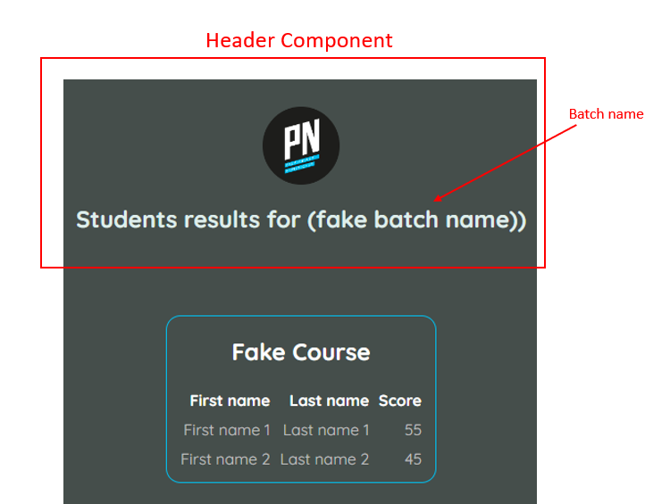

The app will call the Header component with the batch name as a parameter:

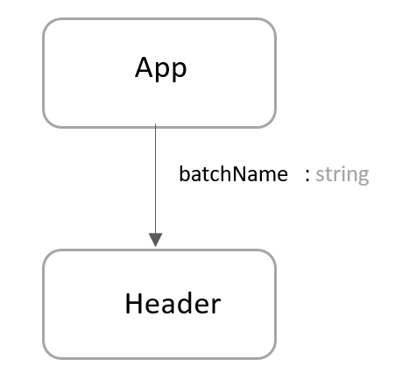

STEP 2 – CREATE THE SCORE COMPONENT
Well done!

Now, you need to create a component Scores component (Scores.jsx file in folder /components)
- This component shall get as a parameter the course name and a list of results
  - Each result is composed of: the first name, last name, and student score
- Your component will need to loop on the list of results and create a table row for each score
- You can test your component by importing the data.js tables in App.jsx

Note: the <main> element in the App.jsx should stay in the App: this is the container of all Scores.

For example, this code should provide the below result:

import {HTML_RESULTS} from "./data.js";
…
<Scores courseName="HTML" courseResults={HTML_RESULTS}></Scores>

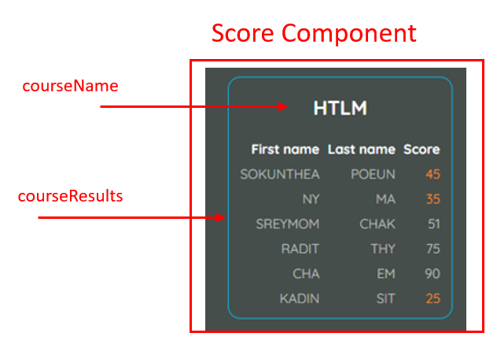

The app will be composed of a Header and many Scores components:
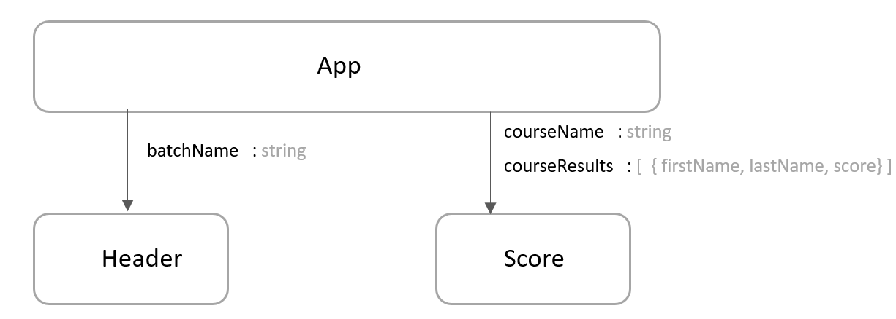

STEP 3 – ORANGE COLOR WHEN SCORE IS BELOW 50
Amazing!

Now you need to color the score in orange if this score is below 50.
- You can use the class. warning to style the <td> accordingly (see the index.css file)

In JSX, you cannot use class keywords; instead, you need to use className.

Tips: you can create a function, which decides the style of the score <td>, depending on a given score value

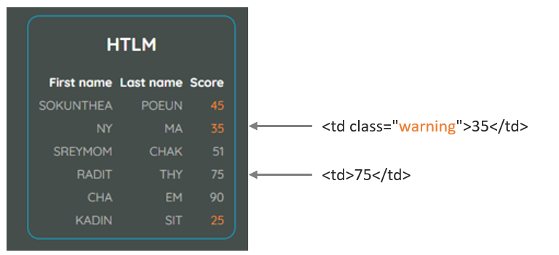

STEP 4 – CREATE A STATISTIC COMPONENT
Amazone!

Finally, we want to add, below the table, a statistic panel, displaying the average, min, and max scores of this table scores.

You are free now to decide how to do it. How to style it? How to compute the statistics?
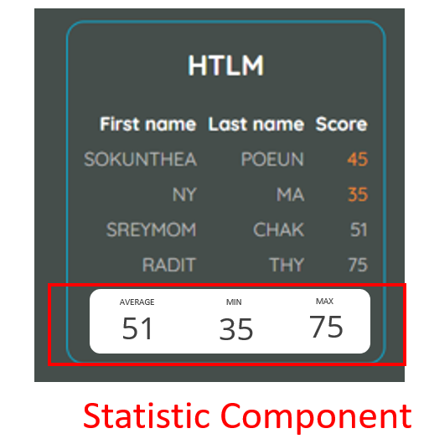

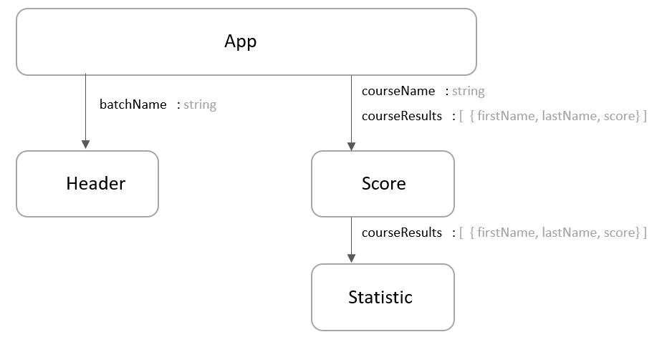

STEP 5 – Display Score for All Courses
Get and display all Data from the data.js

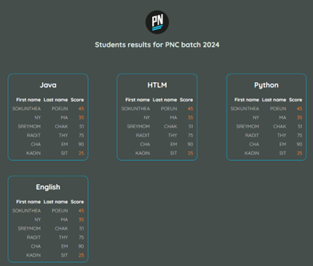

Finished?


